**Hed:** The Wondrous World of Karen Berger

**Subhead:** *Karen Berger ’79, a trailblazer in the comic book industry who has worked on some of the best-known and edgiest books in the history of the genre, embarks on her latest adventure, the Berger Books imprint under the publisher, Dark Horse.*

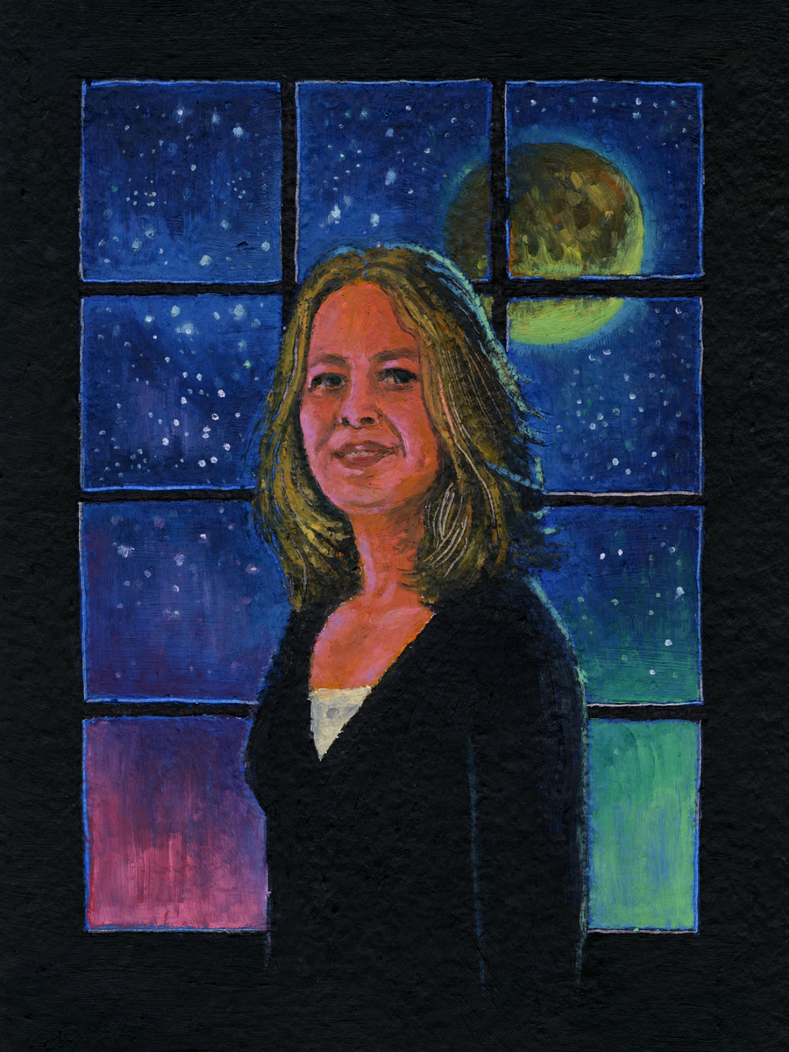

**ILLUSTRATION. CAPTION:** Known as “the mother of weird comics,” Karen Berger steered a generation of readers into dark and shimmering spaces with books that flourished under her Vertigo Comics imprint, including *Sandman*; *V for Vendetta*; *Swamp Thing*; *Y: The Last Man*; and *Preacher*, among others. Written by Robert Jones, Jr. ’06, ’08 M.F.A. Illustration by Paul Gagner ’09 M.F.A.

**Brooklyn Beginnings**

The first time Karen Berger ’79 walked into a comic book shop was during her freshman year at Brooklyn College. She was accompanying her friend John Marc “J.M.” DeMatteis ’76. DeMatteis had recently started writing for DC Comics (DC).

“He dragged me to this old store on Flatbush Avenue,” Berger recalls. “He had sold his first story to Paul Levitz, who was editor of *House of Mystery* and *Weird War Tales,* and wanted to show me his work.”

The shop was called My Friend’s Bookstore. “It was the strangestplace,” Berger says. “It was dusty. The book Marc worked on was kept at the back of the store in a crate, and he had to go back there and dig it out to show me. I thought the whole thing was just so bizarre, you know?” she says. “But I kind of liked his story.”

No one could have imagined then that Berger, who had barely a passing interest in the pulp adventures of superheroes, would go on to become one of the most transformative figures in the comic industry—a figure whose impact is felt to this day as founder of her own company, Berger Books.

Berger’s Brooklyn roots are quite deep. Born and raised in the borough, as were her parents and grandparents, she grew up mostly in the Flatlands section. She comes from a family of Brooklyn College alumni. Berger’s father, Harold Berger, graduated in 1944 with a degree in biology. Her mother, Rita Brandt-Berger, earned a degree in home economics in 1948. And her eldest brother, Bruce Berger, graduated in 1974 with a degree in psychology.

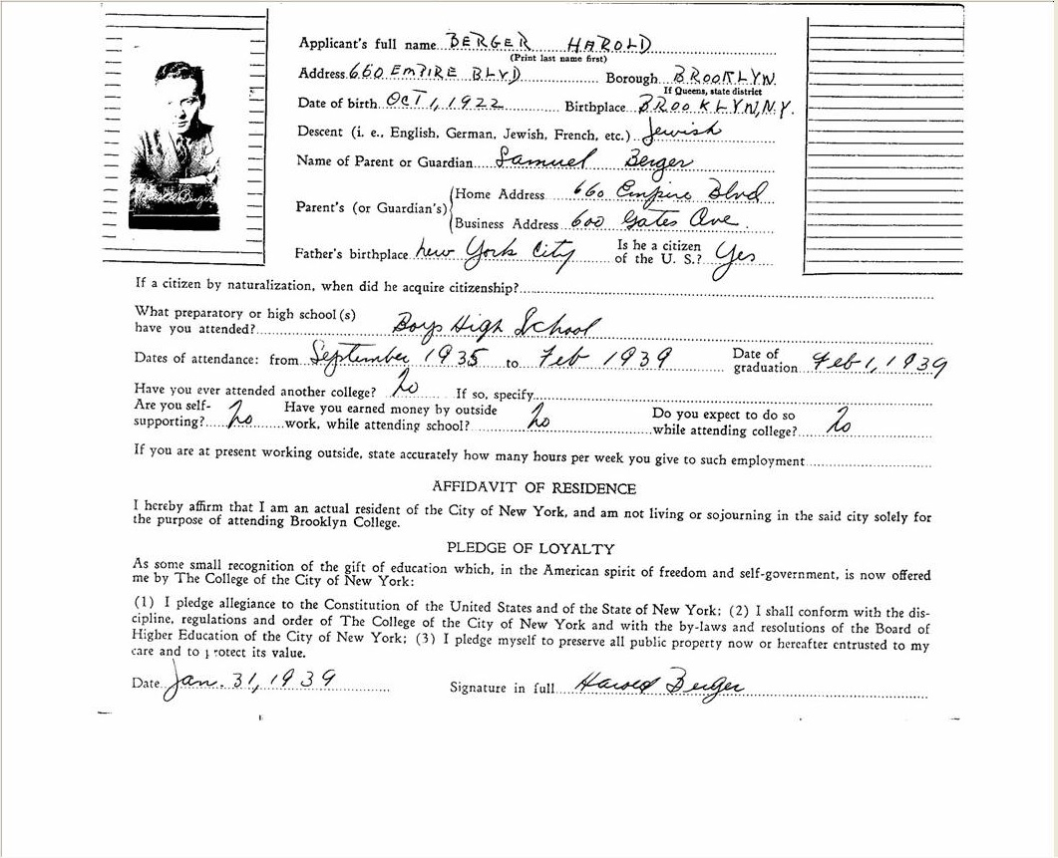

**PHOTO. CAPTION:** Berger’s father, Harold, died in 1960, when Berger was just two years old. His photo and personal data appeared on the back of his Brooklyn College transcript. (Brooklyn College archives)

Berger herself received a bachelor’s degree in English literature, with concentrations in art history and journalism. “I was really into modern art at the time and thought that, with my background, I might get a job at a museum or a magazine, though there were very few magazines that focused on art, and those industries were very tough to break into,” she says.

Broadening her job search, Berger looked for positions throughout the publishing industry and found that most were limited to proofreading—not something she was interested in as a career. As it happened, her friend Marc had started publishing more stories with DC. He mentioned to Berger that his editor was looking for an editorial assistant who was not a comic book reader and who, therefore, would not be distracted from work responsibilities by reading them all day long. Berger promptly applied, and she began working for the publisher in 1979.

**[TRAILER:** <https://youtu.be/VSB4wGIdDwo> **CAPTION:** Wonder Womanis a character Berger helped modernize. The movie starring the heroine was the biggest hit of summer 2017, bringing in $412 million in the United States alone*.***]**

**She’s a Wonder**

DC gave Berger room to grow. To further her budding interest in the field, Levitz provided her with opportunities to work as an assistant editor on books such as *Batman* and *Detective Comics*. She honed her skills and creative talent while working in proximity to some of the most legendary names in geekdom, including former DC publisher Julius “Julie” Schwartz; *Superman* artist Curt Swan; *Shazam* artist Kurt Schaffenberger; *Hawkman* artist Murphy Anderson; Joe Kubert, artist and founder of the Kubert School; and Robert Kanigher, writer of *Wonder Woman,* among many others.

**[RIGHT-SIDE ELEMENT]**

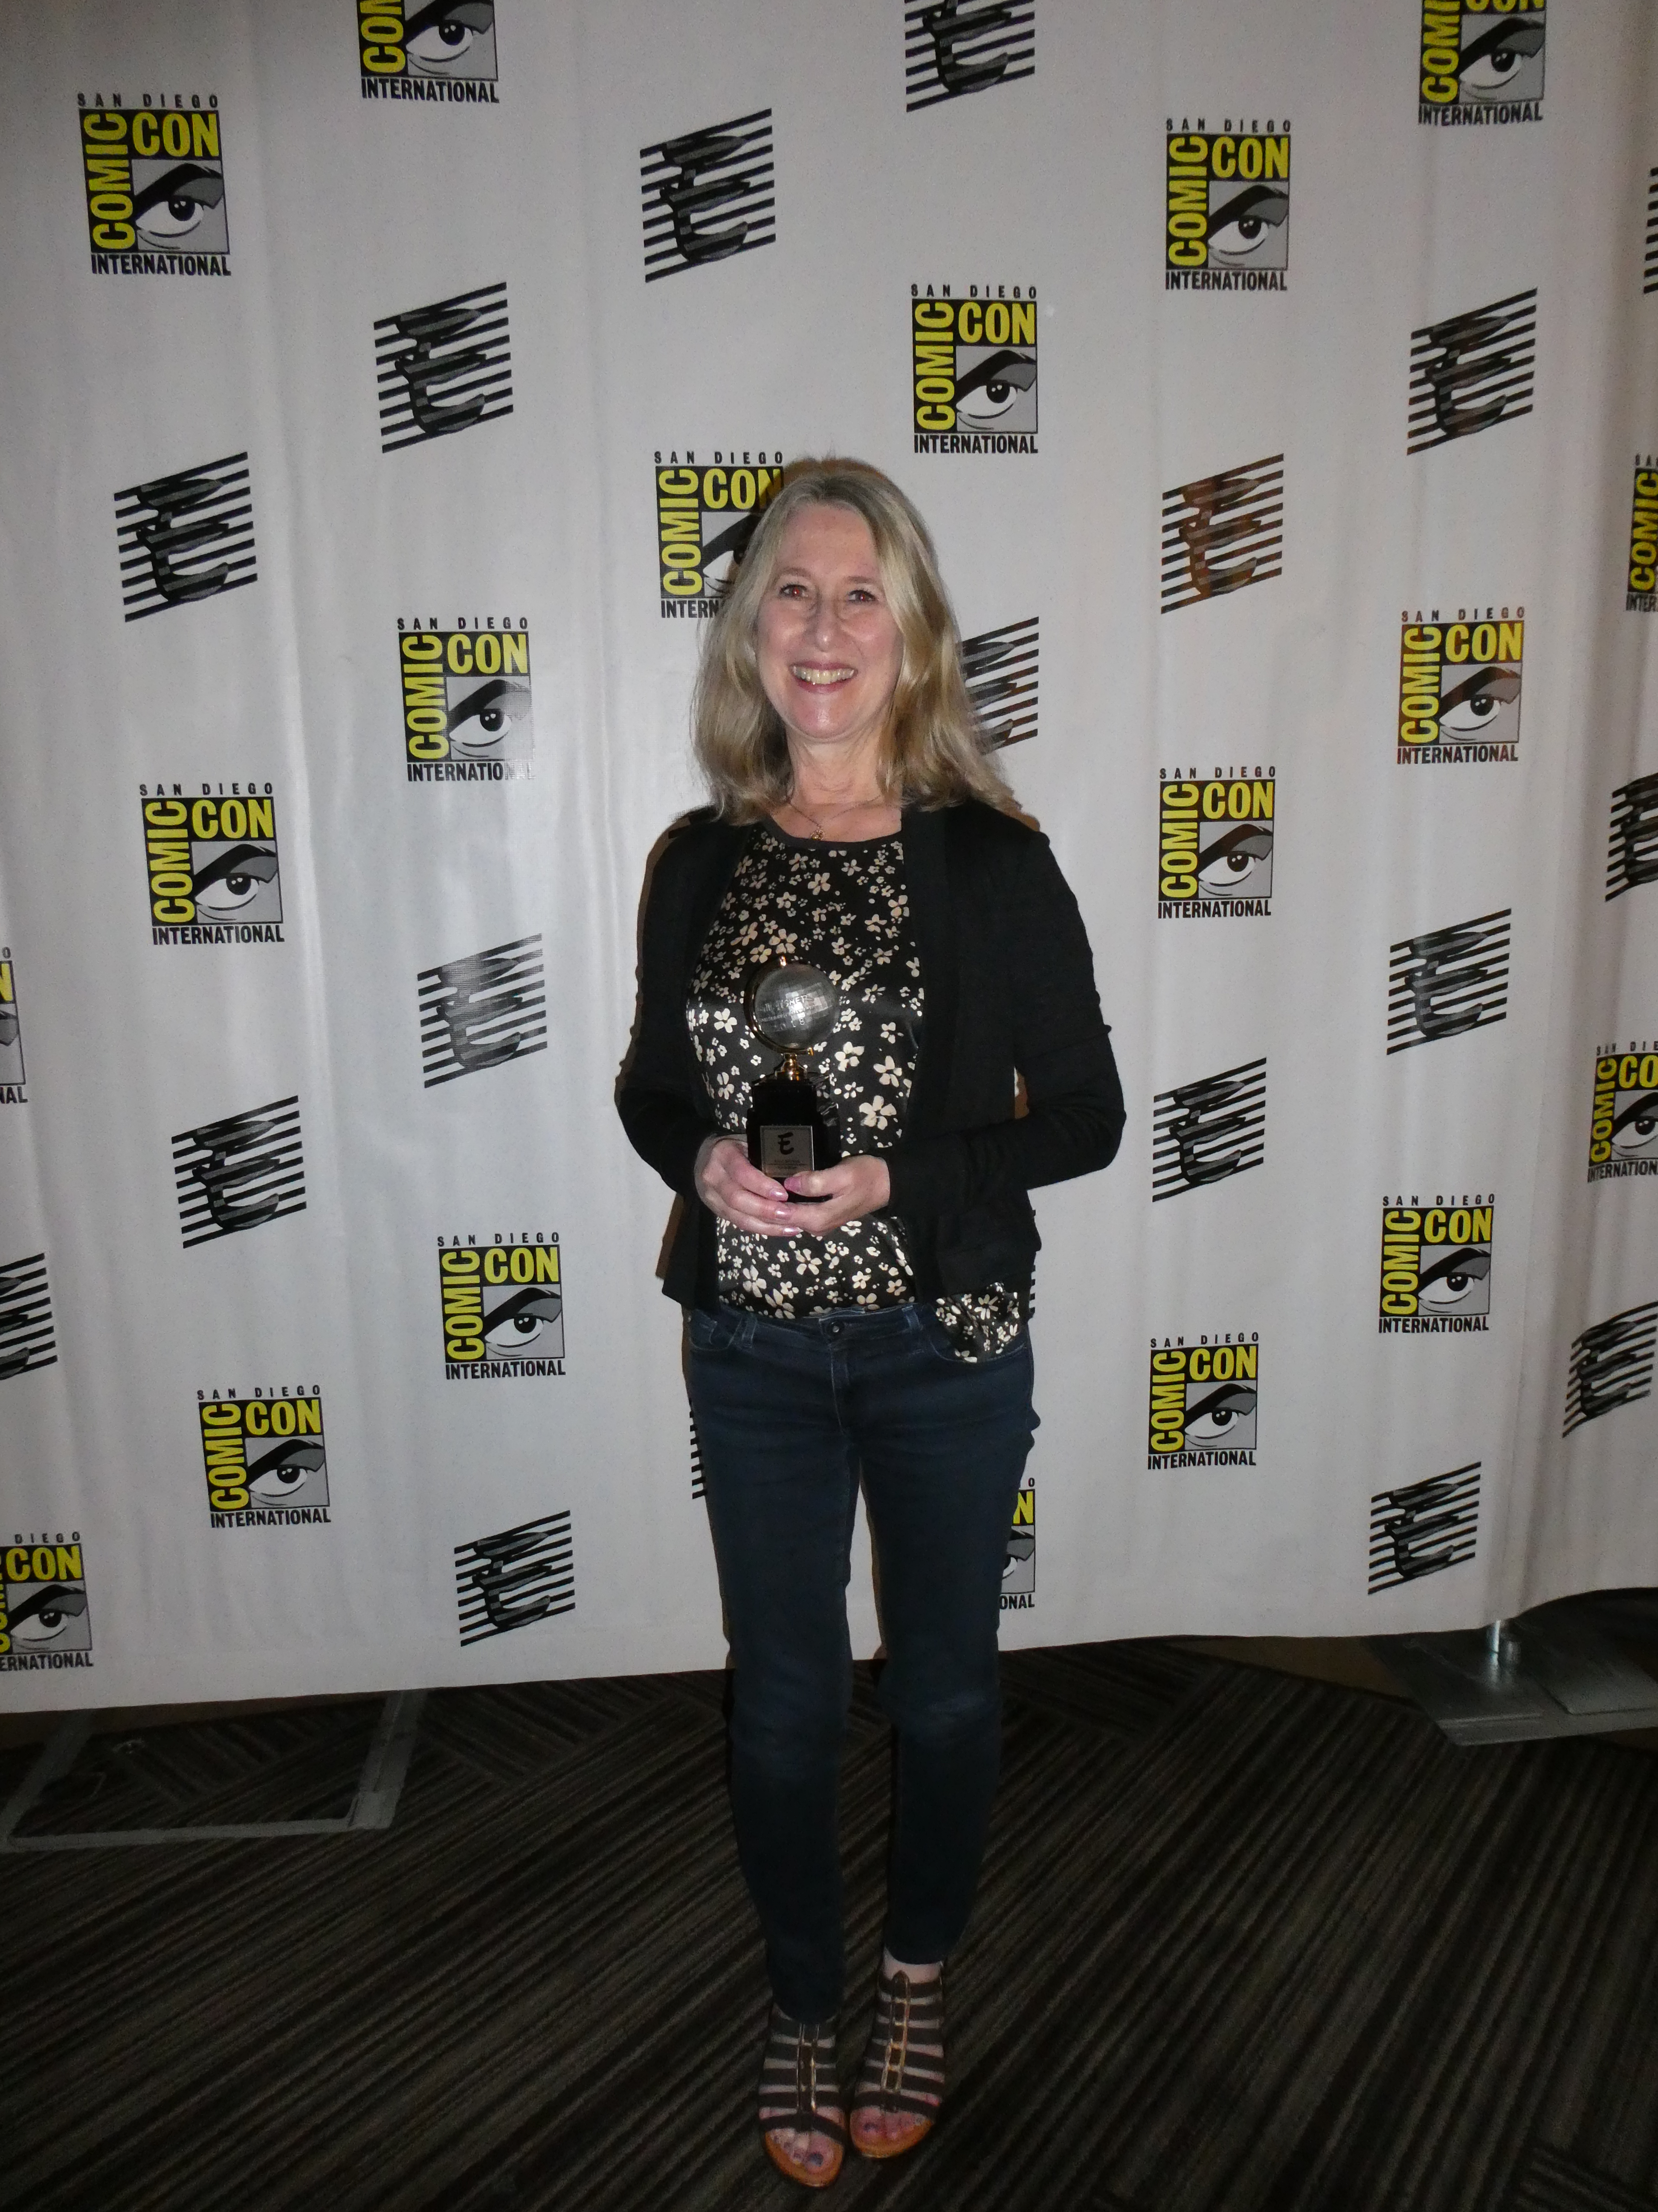

Berger was inducted into the Eisner Hall of Fame at the 2018 San Diego Comic Con, the largest comic book convention in the world.

List of Berger’s Awards:

* Comic Buyer’s Award: Favorite Editor (1997–2005)
* Eisner Award: Best Editor (1992, 1994, 1995)
* Eisner Award: Hall of Fame (2018)
* Inkpot Award: Achievement in Comics (1990)

**(Back to Text)**

Many people have noted with surprise Berger’s ability to thrive in a male-dominated industry. She understands why some might feel that way—particularly during a sociopolitical moment when women across the globe are speaking up about domestic and workplace assault, harassment, and violence via the #MeToo movement. However, Berger says that no obstacles or limitations, institutional or otherwise, were ever imposed upon her because of her gender. For this, she credits Jenette Kahn, who became DC’s publisher in 1976.

“It was almost as though the tone was already set,” Berger says. “Here was a smart, creative, ethical, fearless, risk-taking, brave, amazing, warm, friendly person running the company. It was a very open place. I never felt that, as a woman, I couldn’t get ahead there. I was editing *House of Mystery* six months after I walked in the door. And I was promoted to editorial coordinator in something like a year and a half. Yes, it’s true, there were not that many women compared with the number of men working at the company, but my direct male bosses, Paul and Dick Giordano were extremely encouraging, supportive and huge advocates for my career growth.”

What made Berger’s tenure at DC so unique was her approach to the franchises. She did not view the heroes and their foils through the lens of a fan, but searched for what distinguished them from standard cartoonish tropes. She drew on the specific elements that helped the characters transcend the funny pages and inhabit a space in the broader American cultural zeitgeist. For example, Berger’s stewardship of *Amethyst, Princess of Gemworld* embraced its fantasy elements; in *The Legion of Super-Heroes,* she steeredthe focus toward science fiction; for *Swamp Thing*, she encouraged an emphasis on the horror and romantic aesthetics; and with *Wonder Woman,* she shepherdedthe interplay of mythology and politics. Berger was the editor during writer/artist George Pérez’s seven-year run, which is credited with reinvigorating Wonder Woman with the feminist perspective her creator—a psychiatrist and the inventor of the lie detector, William Marston Moulton—intended her to have. And Berger’s influence on all of these creations has been lasting. Film director Patty Jenkins states that it was Pérez’s version of Wonder Woman that [inspired her approach in the 2017 blockbuster film](https://www.cbr.com/wonder-woman-patty-jenkins-george-perez-influence/).

Berger’s visionary guidance would provide the basis of an imprint that transformed the industry and broke the boundaries for what comic books could be.

**[SLIDESHOW]**

*100 Bullets* by Brian Azzarello and Eduardo Risso

*Death: The High Cost of Living* © and ™ DC Comics

*Fables* by Bill Willingham and Mark Buckingham

*Hellblazer*  © and ™ DC Comics

*The Invisibles* by Grant Morrison

*Preacher* by Garth Ennis and Steve Dillon

*Sandman* © and ™ DC Comics

*Swamp Thing* © and ™ DC Comics

*V for Vendetta* © and ™ DC Comics

*Y: The Last Man* by Brian K. Vaughan and Pia Guerra

**(Back to Text)**

**Experiencing Vertigo**

“It all happened very organically,” Berger says about the founding of Vertigo Comics, an imprint of DC that took a decidedly mature and experimental approach to comic books. “I was working with British writer Alan Moore on *Swamp Thing*, and Alan, as we all know, changed the face of comics,” says Berger. “Jenette Kahn had told me that there were a lot of talented people living in England, and she said, ‘Why don’t you become our ambassador as we begin to work with more artists and writers there?’”

Berger started to curate and cultivate the talent pool in England, becoming acquainted with artists like Brian Bolland and Dave Gibbons. At the time, DC was experiencing a kind of renaissance and revamping staple brands like Wonder Woman, Superman, and Batman for a modern audience. Aside from Wonder Woman, Berger was interested in getting more-obscure characters on the DC roster. She began searching for creators, some of whom were at the earliest stages in their careers, whose work she enjoyed or in whom she saw great potential. Coupled with several of the books she was already editing (*Sandman*; *Swamp Thing*; *Shade, the Changing Man*), these edgy, literary-minded, in-your-face political monthlies (which were then known colloquially as “the Berger Books”) caused quite a stir in the industry.

**[Expanding Block: Comic book superstars discuss the impact Karen Berger has had on their careers.]**

G. Willow Wilson (writer of Air, Invisible Kingdom, Ms. Marvel, Vixen, Wonder Woman)

When I was just starting out in comics in my mid-twenties, Karen Berger was more than just an editor to me—she was a mentor. Her guidance was tremendously important to me at that time. The great thing about Karen is that she gives you latitude to experiment. She doesn’t try to put you in a box. That was rare then and even rarer now. She’s kind of an auteur without a single theme—that’s how she could go from editing experimental fantasies like Sandman and V For Vendetta to journalism and cultural criticism like Incognegro and Sentences. She chooses projects that prefigure our broader cultural conversations by five or 10 years—that’s why so many of the books she edits end up feeling so prophetic.

Phil Jimenez (artist and/or writer of Invisibles, Otherworld, Tempest, Wonder Woman, Wonder Woman: Historia)

There are few people who have impacted my career in comic books in the way Karen Berger has. When I started flipping through my favorite comics at the time, I realized that all of them—from Wonder Woman to Sandman and Animal Man to Legion of Super-Heroes—were edited by one person: Karen Berger. Thus, it became my mission to work for her.

I met Karen briefly at a convention, and when I moved from California to NYC to attend college, I immediately called her up at DC Comics (which is just what a young novice would do) and asked if I could see her at the office. Surprisingly, she said yes, and after a few failed attempts, I finally got to visit her there. She gave me a script to draw from and practice with. Over the next two years, she was kind enough to review my portfolio a handful of times—and I was hired to draw my first comic the summer after my sophomore year of college.

Karen’s kindness and willingness to help me, a persistent young freelancer, helped launch my career by giving me hope and guidance as well as actual scripts. [She is] someone I even got to work for now and then when she started the famed Vertigo imprint (I drew Invisibles and my creator-owned book, Otherworld). Karen’s impact on my career, and my perception of what comics could and should be, is hard to overstate. Her willingness to help me and to champion a kind of content that would change an industry make Karen a vital touchstone in the history of my career, and her legacy includes the young people whom I’ve influenced and encouraged to pursue their dreams of art in the same way.

**[Back to Text]**

As this was happening, Berger was on maternity leave and received a call from DC’s then vice president and executive editor, Dick Giordano. He invited her to attend, when she returned, a meeting with Levitz, Kahn, and himself to talk about the possibility of Berger expanding her work at DC. Because of the buzz around her titles and their success in the market, they wondered whether she would be interested in helming her own line of books.

“In a heartbeat, I said yes.”

Founded in 1993, and based on Berger’s own business/publishing plan, Vertigo Comics is now among the imprints that have won the most awards in the history of the industry, with many of its titles perennial best-sellers. Some of its best-known books include *Sandman;* *Death: The High Cost of Living* (the first title officially launched under Vertigo); *V for Vendetta*; *Hellblazer; Preacher; and Y: The Last Man*. Of those titles, two have been adapted for film and two for television. Berger’s model was to launch two new series every month—one that was a “weird” take on a pre-existing DC property, and the other that was an original, creator-owned property (in which the writers and artists retain the legal ownership rights of the material). The latter was particularly groundbreaking in an industry whose terms were previously “work-for-hire,” meaning that all work created by the writers and artists belonged to the publisher in perpetuity.

Berger’s influence on the way the comic book industry works, how it creates stories, who it permits to tell stories, and what those stories look and feel like cannot be overstated. She thinks the title “pioneer” is a generous one and feels lucky to have been encouraged along every step of her career. She credits the writers and artists she worked with, and the synchronicity between them, for bringing about the trailblazing material that shaped a generation of readers. When Berger decided to leave Vertigo in 2012, news of her departure reverberated throughout the industry. *The New York Times* published a [feature story on her career](https://www.nytimes.com/2013/05/30/books/comics-mother-of-the-weird-stuff-is-moving-on.html), deeming her “comics’ mother of the weird stuff.”

Berger looks back on her years at Vertigo with high regard for her colleagues. “Jenette, Paul, and Dick are/were great people, great mentors, great believers in creative freedom, new ideas, shaking things up, taking chances and risks. It was wonderful to be able to have that support—especially at a large company that was owned by a corporation, Warner Bros. The company now is quite different: different management, much more of a corporate atmosphere, which was one of the reasons why I wound up leaving.”

**[SLIDESHOW]**

*The Alcoholic.* Writer: Jonathan Ames. Artist: Dean Haspiel. Cover Artist: Dean Haspiel.

*Hungry Ghosts*. Writers: Anthony Bourdain, Joel Rose. Artists: Sebastian Cabrol, Vanesa Del Rey, Francesco Francavilla, Irene Koh, Leo Manco, Alberto Ponticelli, Paul Pope, Mateus Santolouco. Colorist: Jose Villarrubia. Cover Artist: Paul Pope.

*Incognegro: A Graphic Mystery*. Writer: Mat Johnson. Artist: Warren Pleece. Cover Artist: Warren Pleece.

*Incognegro: Renaissance*. Writer: Mat Johnson. Artist: Warren Pleece. Cover Artist: Warren Pleece.

*Invisible Kingdom*. Writer: G. Willow Wilson. Artist: Christian Ward. Cover artist: Christian Ward.

*LaGuardia*. Writer: Nnedi Okorafor. Artist: Tana Ford.

*Mata Hari*. Writer: Emma Beeby. Artist: Ariela Kristantina. Colorist: Pat Masioni. Cover Artists: Ariela Kristantina and Pat Masioni.

*Olivia Twist*. Writers: Darin Strauss and Adam Dalva. Artist: Emma Vieceli.

*The Originals*. Writer/Artist: Dave Gibbons.

*The Seeds*. Writer: Ann Nocenti. Artist: David Aja.

*She Could Fly*. Writer: Christopher Cantwell. Artist: Martin Morazzo.

**Triumph of the Imagination**

You can’t keep a “wonder woman” like Berger down. In 2018, after a five-year hiatus from mainstream comics that saw her working in television development and doing some independent and freelance editorial consulting, Berger launched the first comic book imprint to be headed by a woman and whose name contained hers: Berger Books. When selecting titles for Berger Books, which is published through Dark Horse Comics, Berger employs the same processes, wisdom, and eye for talent that she used to make Vertigo such a success.

**[VIDEO:** <https://youtu.be/q-wq-yqdytg>. **CAPTION:** The trailer for *Surgeon X* gives readers an inside look at the wildly imaginative comic.**]**

What led Berger to return to comics?A book titled *Surgeon X*, published by Image Comics, which she decided to edit. Her work on the project was unlike any of her previous experiences: together with documentary filmmaker turned comic book writer Sara Kenney, she consulted with a board of medical professionals to ensure that *Surgeon X*’s representation of the field was as accurate as possible. Berger also worked with Kenney and a mulitiple artists in creating created an [app as a companion piece](http://ew.com/article/2016/09/23/new-comic-surgeon-x-will-come-enhanced-app/) for the book.

This contemporary approach to storytelling made Berger realize that she “really missed comics” and that she wanted something to focus on full time, so she began the work of making Berger Books a reality.

**[VIDEO:** <https://youtu.be/Qx9pW7jAV8U> **CAPTION:** Berger talks about the launch of Berger Books and its inaugural title, *Hungry Ghosts*.**]**

“Dark Horse is very progressive and totally creator-supportive company. They publish great-quality material with very high production values. At the end of the day it’s all about the book. It’s all about how you collect a story into a graphic novel and keep it on the shelf in stores. I have a lot of respect for publisher Mike Richardson and the company he built. I called him up, and he pretty much said, ‘Sure, Karen. I’d love to work with you.’ ”

Working from her home in Maplewood, New Jersey, Berger began to build the imprint from the ground up, with the assistance of her husband, Richard Bruning, a graphic designer, cartoonist, editor, and writer who designed the logos for *Watchmen* and *Dark Knight Returns* for DC. Berger Books launched in January 2018 with five titles: *Hungry Ghosts* (the last published work of celebrity chef, author, and travel documentarian Anthony Bourdain, who died earlier this year), *Incognegro, Mata Hari, The Originals*, and *The Seeds.* Recently, the imprint has expanded its lineup to include [*The Alcoholic*](http://comicbook.com/comics/2018/02/27/dark-horse-the-alcoholic-tenth-anniversary-edition/)*,* [*Invisible Kingdom*](https://www.hollywoodreporter.com/heat-vision/dark-horse-announces-invisible-kingdom-comic-con-2018-1127541)*,* [*LaGuardia*](http://www.syfy.com/syfywire/exclusive-berger-books-new-comic-laguardia-brings-interstellar-travel-down-to-earth)*,* [*Olivia Twist*](https://www.pastemagazine.com/articles/2018/05/exclusive-novelist-darin-strauss-launches-olivia-t.html)*, and* [*She Could Fly*](http://www.comicsbeat.com/berger-books-expands-lineup-with-she-could-fly/). Berger intends to keep the line relatively small so that she can personally guide each title. The reception has been, in classic Berger fashion, incredible.

**[VIDEO:** <https://youtu.be/kGbgzo4zdt4>. **CAPTION:** Berger sits down with the SyFy channel to discuss Incognegro, one of the popular titles in the Berger Books lineup.**]**

“I’ve always edited comics that I wanted to read myself,” she says. “That may sound kind of simple or maybe even glib, but it’s not meant to. I understand we want to make money and that, as publisher and editor, you have to keep that in mind, too. But I hope that putting the quality of the content first will help us reach readers.”

For more information about Berger Books, visit the [Dark Horse website](https://www.darkhorse.com/Blog/2606/berger-books-dark-horse).

**[SIDEBAR]**

**Comical Brooklyn!**

Karen Berger ’79 leads quite a few people who either graduated from or studied at Brooklyn College before breaking into the comic book industry. Here are a few notable creators whose super-heroic imaginations were sparked under our iconic clock tower.



**Saladin Ahmed ’02 M.F.A.:** The Hugo Award–winning novelist is currently working on *Black Bolt* for Marvel Comics and the creator-owned *Abbott* for Image Comics. He, along with artist Christian Ward, recently [won an Eisner Award for Best New Series](https://www.newsarama.com/40995-2018-eisner-awards-winners-full-list.html).

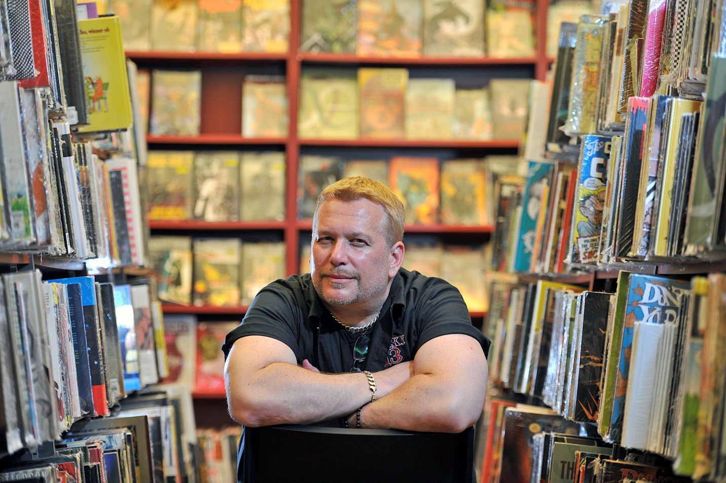

**Adam Glass (attended 1989–1992):** The writer, screenwriter, and television producer has worked on *Deadpool* and *Luke Cage* for Marvel Comics, *Suicide Squad* for DC Comics, and *Rough Riders* for Aftershock Comics.

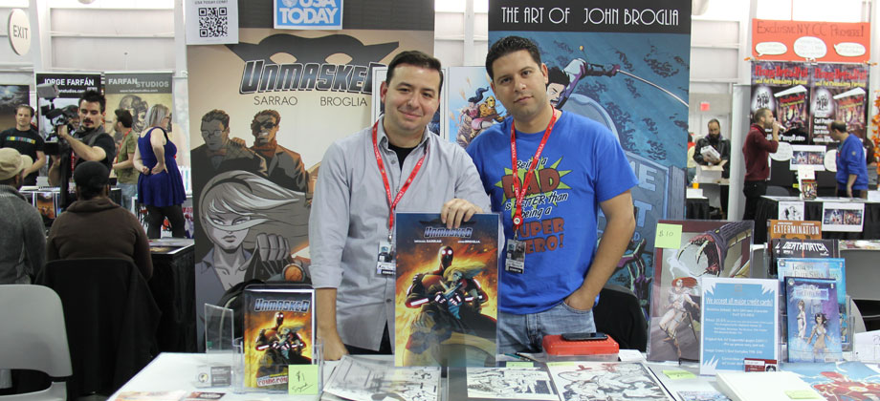

**Michael Sarrao ’02 (left):** The writer raised nearly $7,000 above his $8,000 Kickstarter goal to finance his independent comic book, *Unmasked*.